LAB ASSIGNMENT 10
NAME : G.VARSHITH REDDY
ID : 2503A52L15
BATCH – 16 AIML

Task Description #1 – Syntax and Logic Errors
Task: Use AI to identify and fix syntax and logic errors in a faulty
Python script

Sample code which gives error:
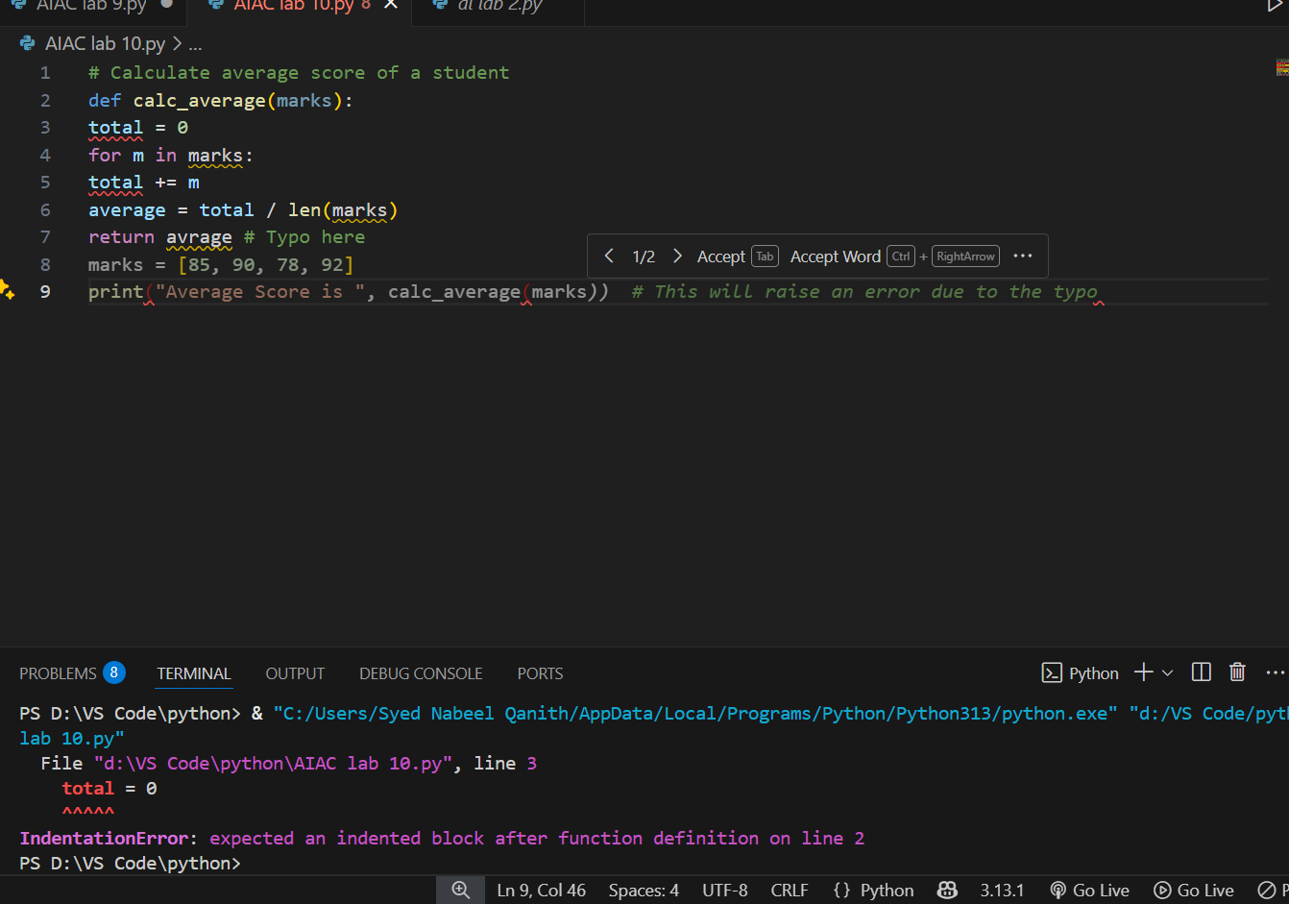

Prompt: correct the code and give me appropriate output.

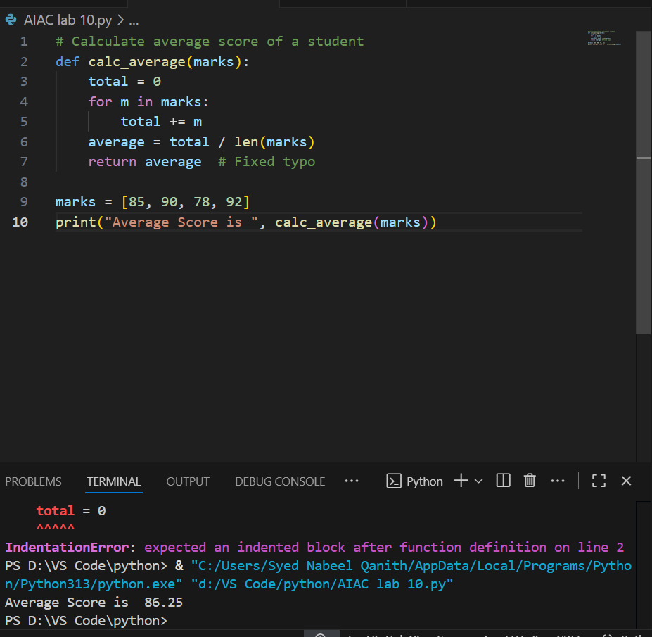
Expected Output:
• Corrected and runnable Python code with explanations of the
fixes

Task Description #2 – PEP 8 Compliance
Task: Use AI to refactor Python code to follow PEP 8 style guidelines.

Prompt: Use AI to refactor Python code to follow PEP 8 style guidelines.

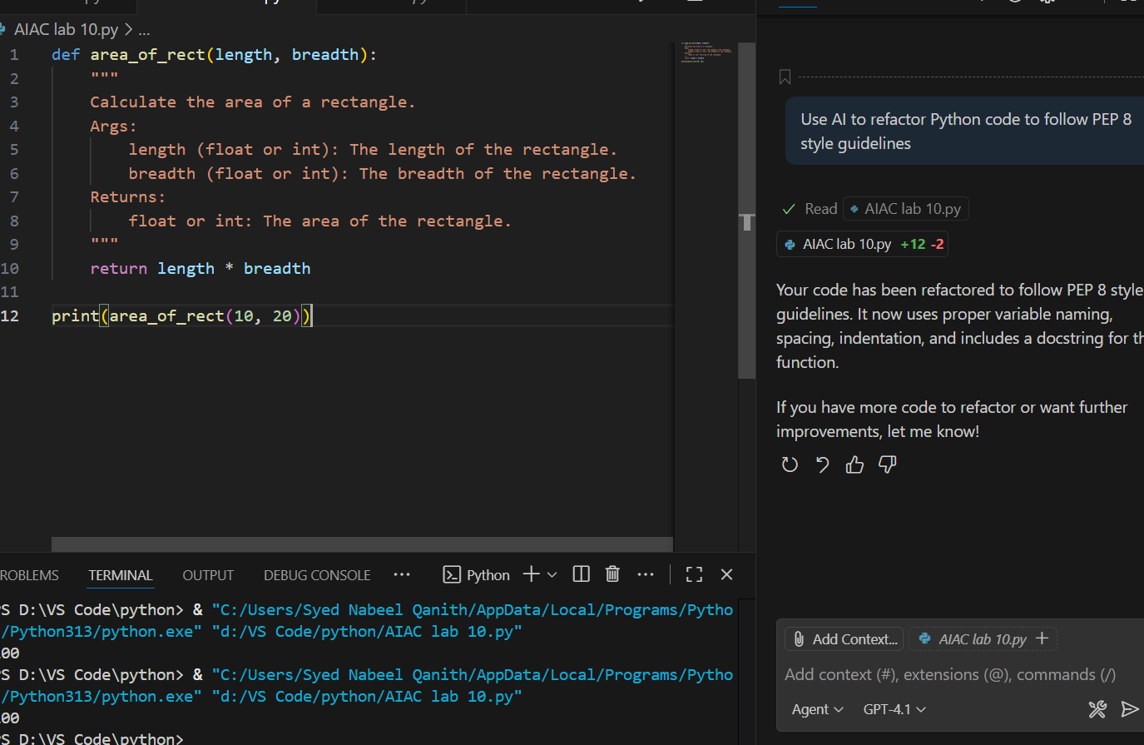

Expected Output:
• Well-formatted PEP 8-compliant Python code.

Task Description #3 – Readability Enhancement
Task: Use AI to make code more readable without changing its logic.
Prompt:Make Code more readable without changing its logic.

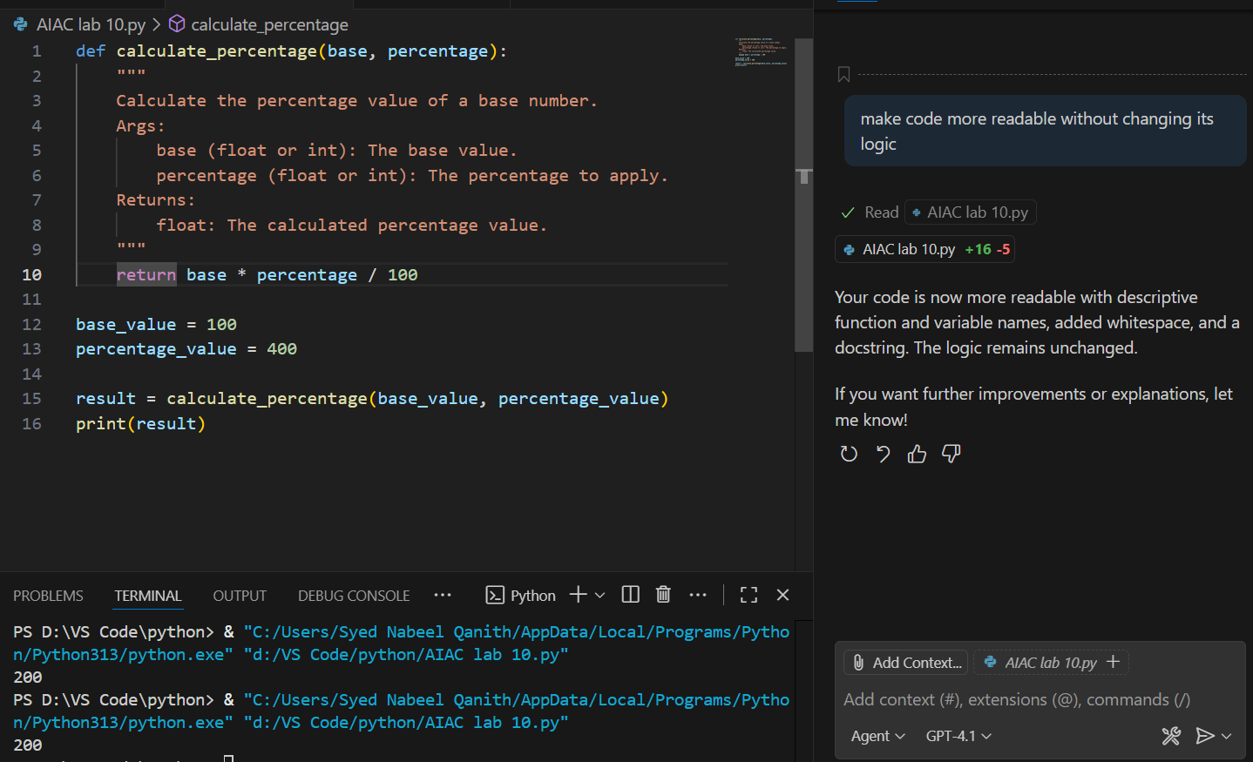
Expected Output:
• Python code with descriptive variable names, inline comments,
and clear formatting.

Task Description #4 – Refactoring for Maintainability
Task: Use AI to break repetitive or long code into reusable functions

Prompt: break this repeatative long code into reuasability functions
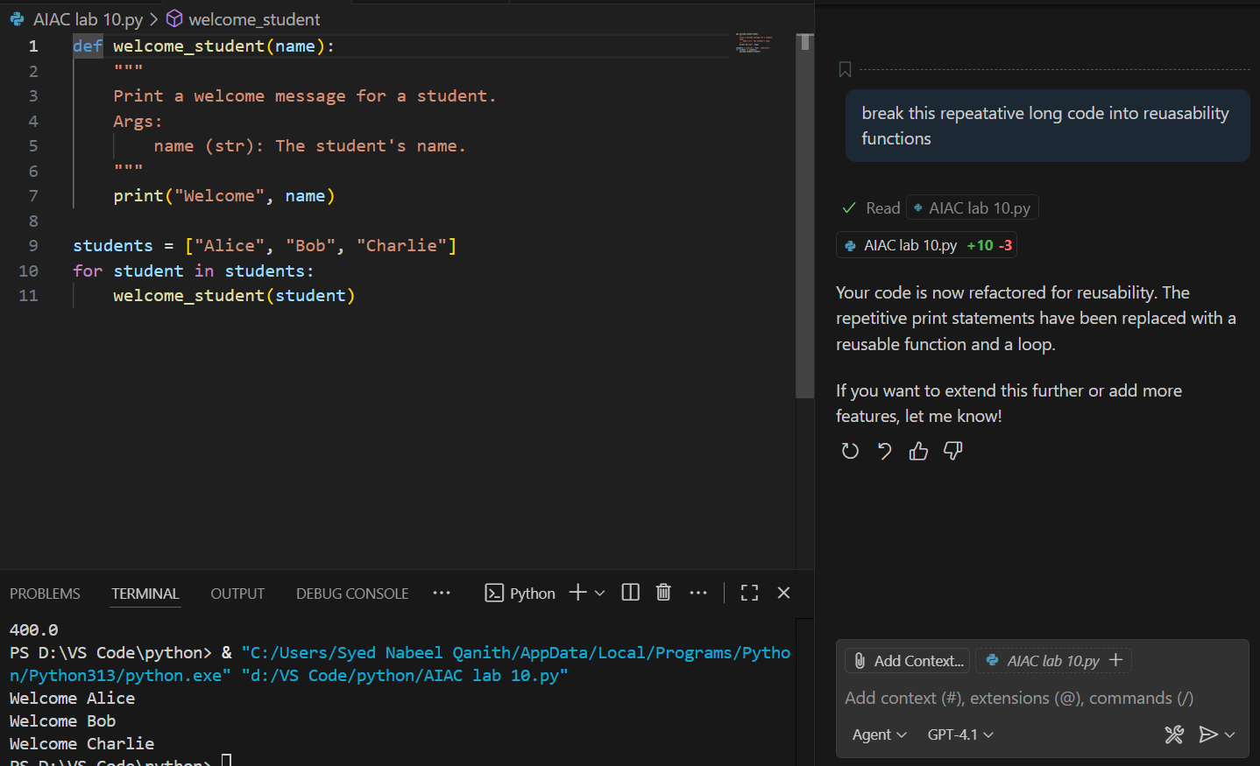
Expected Output:
• Python code with descriptive variable names, inline comments,
and clear formatting.

Task Description #5 – Performance Optimization
Task: Use AI to make the code run faster

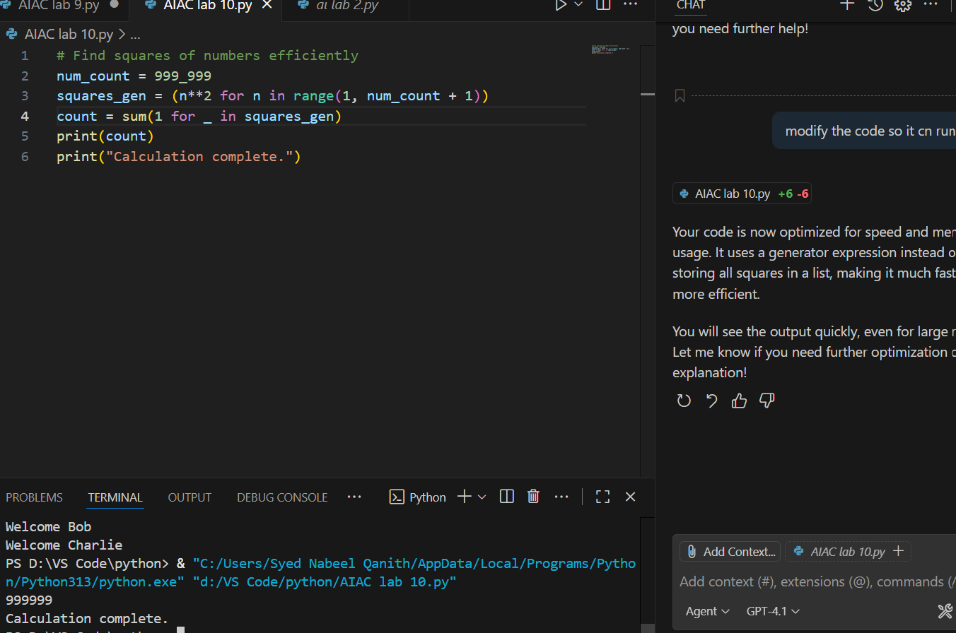
Expected Output:
• Optimized code using list comprehensions or vectorized
operations

ask Description #6 – Complexity Reduction
Task: Use AI to si Expected Output:
• Optimized code using list comprehensions or vectorized
operationsmplify overly complex logic.
Sample Input Code:
def grade(score):
if score >= 90:
return "A"
else:
if score >= 80:
return "B"
else:
if score >= 70:
return "C"
else:
if score >= 60:
return "D"
else:
return "F"
prompt:Simplify this overly comlex prompt.

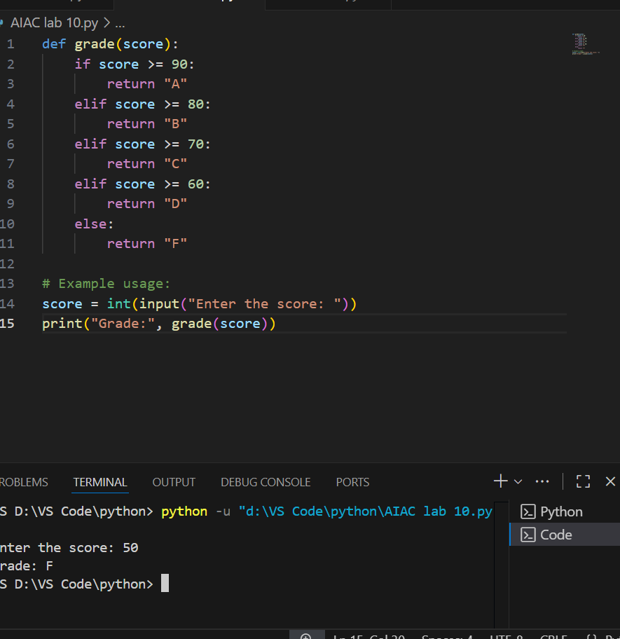

Expected Output:
• Cleaner logic using elif or dictionary mapping

